CSA15- CLOUD COMPUTING AND BIG DATA ANALYTICS
EXPERIMENT 1
Aim
To create a simple cloud-based software application and deploy it using a Cloud Service Provider (CSP) to demonstrate the Software as a Service (SaaS) model.
Procedure
- Develop a simple web application (e.g., Login, To-Do List, or Student Registration System).
- Create an account on a Cloud Service Provider such as ZOHO creator
- Upload and deploy the application on the cloud platform.
- Configure the application to be accessible through a public URL.
- Test the application from different devices using the internet.
- Verify that users can access and use the application as a cloud-based service (SaaS)

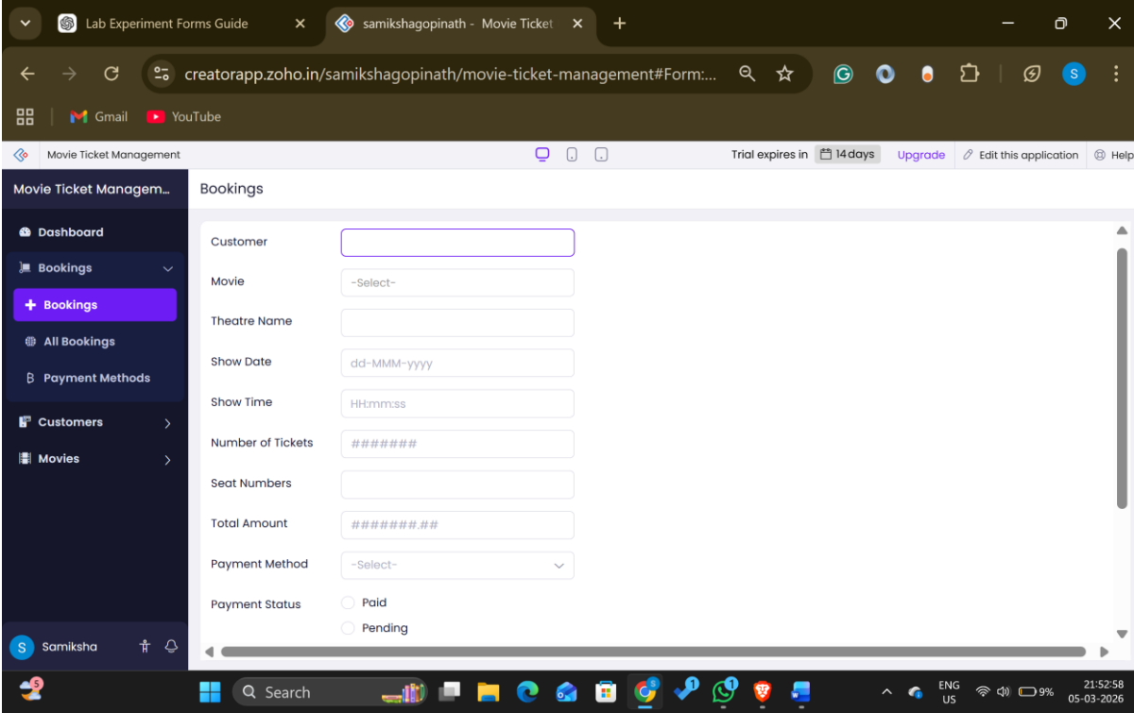

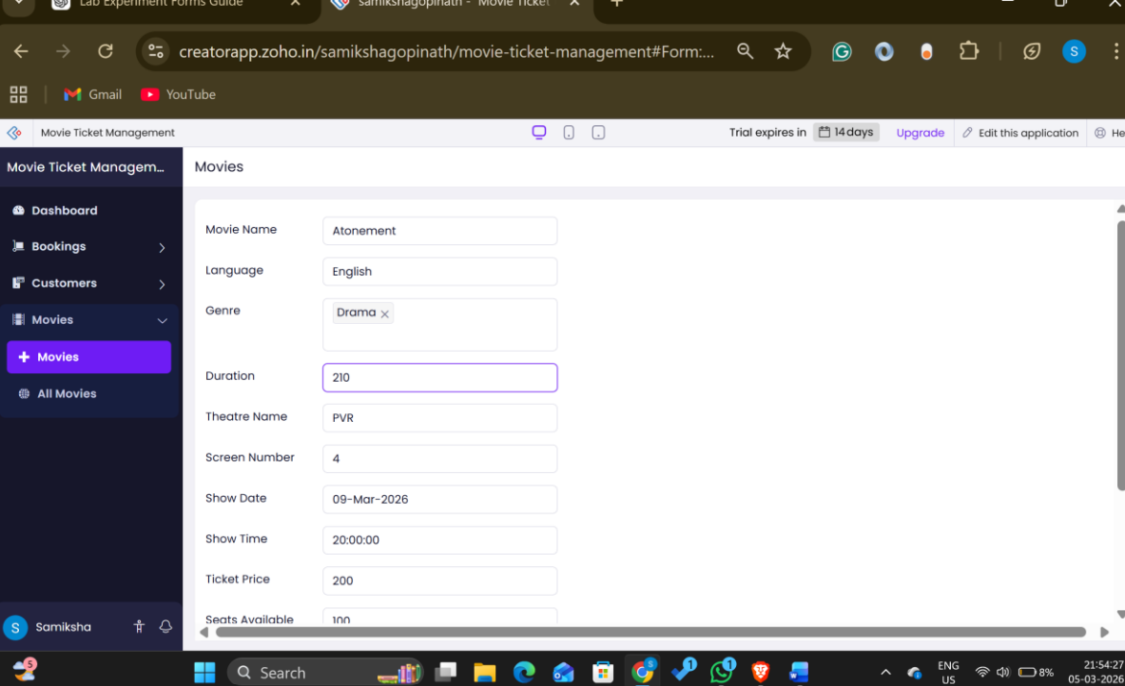

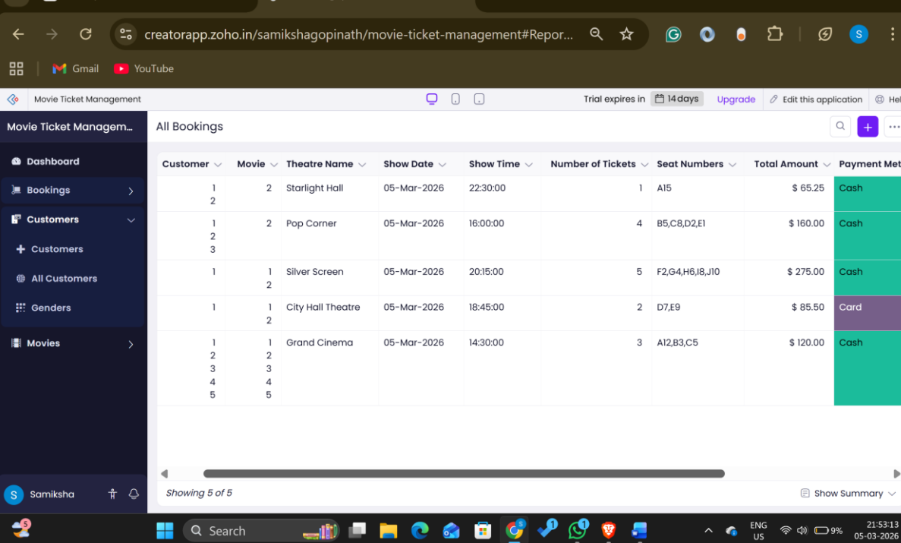
Result
The cloud software application was successfully deployed on a Cloud Service Provider and accessed through the internet, demonstrating the Software as a Service (SaaS) model.

